**Assignment -1**

|  |  |
| --- | --- |
| Assignment Date | 17 September 2022 |
| Team ID | PNT2022TMID38850 |
| Project Name | EMERGING METHODS FOR EARLY DETECTION OF FOREST FIRES |
| Student Name | SHAM S |
| Student Roll Number | 421219104016 |
| Maximum Marks | 2 Marks |

**Question-1.** Split this string

s = "Hi there Sam!"

**Solution:**

**s.split(' ')**

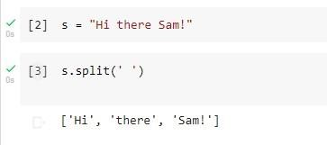

**Question-2.**

Use .format() to print the following string.

Output should be: The diameter of Earth is 12742 kilometers.

**Solution:**

**planet = "Earth" diameter = 12742**

**print( 'The diameter of {} is {} kilometers.' .format(planet,diameter));**

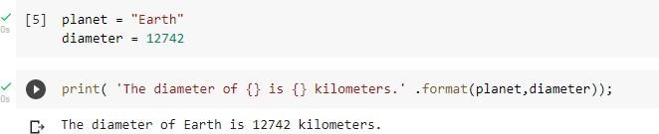

**Question-3.**

In this nest dictionary grab the word "hello"

d = {'k1':[1,2,3,{'tricky':['oh','man','inception',{'target':[1,2,3,'hello']}]}]}

**Solution:**  **d['k1'][3]['tricky'][3]['target'][3]**

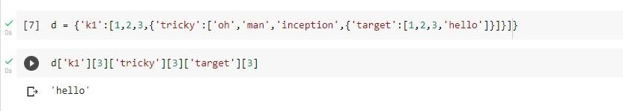

**Question-4.**

4.1 Create an array of 10 zeros?

**Solution:**

**import numpy as np array=np.zeros(10) print("An array**

**of 10 zeros:") print(array)**

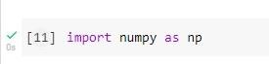

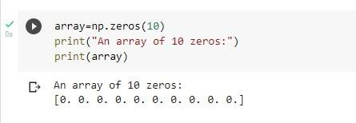

4.2 Create an array of 10 fives?

**Solution:**

**import numpy as np array=np.ones(10)*5 print("An**

**array of 10 fives:") print(array)**

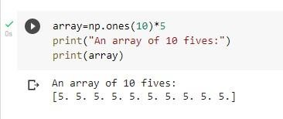

**Question-5.**

Create an array of all the even integers from 20 to 35

**Solution:**

**import numpy as np array=np.arange(20,35,2)**

**print("Array of all the even integers from 20 to 35") print(array)**

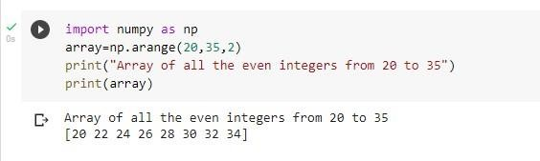

**Question-6.**

Create a 3x3 matrix with values ranging from 0 to 8

**Solution:**

**import numpy as np matrix = np.arange(0,**

**9).reshape(3,3) matrix**

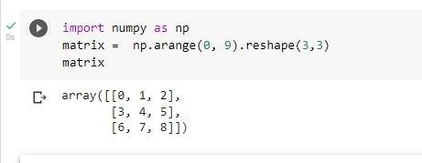

**Question-7.**

Concatenate a and b

a = np.array([1, 2, 3]), b = np.array([4, 5, 6])

**Solution:**

**import numpy as np a = np.array([1, 2, 3]) b= np.array([4, 5, 6]) array = np.concatenate((a, b)) array**

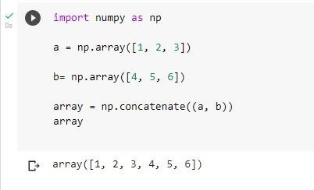

**Question-8.**

Create a dataframe with 3 rows and 2 columns

**Solution:**

**import pandas as pd d = {'a': [1, 'A'],'b': [2, 'B'],'c': [3,**

**'C']} f = pd.DataFrame(d) f**

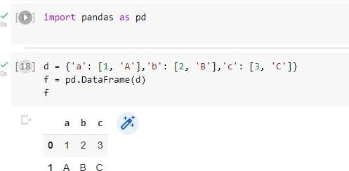

**Question-9.**

Generate the series of dates from 1st Jan, 2023 to 10th Feb, 2023 **Solution:**

**dates = pd.date_range("1/1/2023", "10/02/2023") dates**

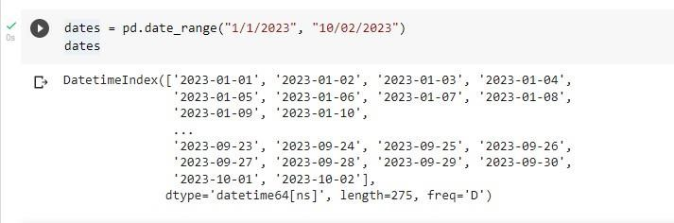

**Question-10.**

Create 2D list to DataFrame

lists = [[1, 'aaa', 22], [2, 'bbb', 25], [3, 'ccc', 24]]

**Solution:**

**lists = [[1, 'aaa', 22], [2, 'bbb', 25], [3, 'ccc', 24]] df =**

**pd.DataFrame(lists) df**

